PARAGON CONVENT SCHOOL
CHANDIGARH
CH-3 Fibre to Fabric
Summary:
- Wool and silk are animal fibres made up of proteins.
- Rearing of sheep means to look after the sheep by providing them food, shelter and health care.
- Wool is obtained from sheep , it includes following steps: 1) shearing 2) scouring 3) sorting 4)combing 5)dyeing 6) spinning.
- Sorter’s disease is an occupational disease caused by bacillus anthracis among workers of wool industry.
- The rearing of silkworms for obtaining silk is called sericulture.
- The life cycle of silk moth involves the following stages:
eggslarvapupa-cocoonadult silk moth.
- To obtain the silk fibre from cocoons they are boiled in hot water, this loosens the fibre but in this process larvae in cocoons die.
Answer key:
M.C.Qs page no. 35
- d
- c
- c
- b
- c
M.C.Qs page no.37
- a
- c
- b
- c
- b
SECTION A
A. Oral questions.
- Air gets trapped in the spaces between the wool fibres. Since air is a bad conductor of heat it does not allow the body heat to escape and keeps the body warm during winters.

- The silky covering spun by the silk worm for its protection is called cocoon. It is made by silkworm to protect its development as Pupa.

- The rearing of silkworms for obtaining silk is called sericulture.

- Throwing prevents the Silk from splitting into individual fibres.
B. science quiz.
- Animal fibres are wool and Silk.
- Plant fibres are cotton and jute.
- Lohi ,Marwari, pathanwadi and Nali.
- Shearing
- Lohi
WORKSHEET
- Tick the correct answer
- b
- d
- c
- c

- Circle the odd one out.
- Reeling all others are processes of obtaining wool where as reeling is used in obtaining silk.
- Tadpole all others are the stages in life cycle of silkworm where as tadpole is a baby frog.
- Horse all others give wool or fur where as horse does not give wool or fur.

- Fill in the blanks.
- Cocoon
- Shearing
- Mountain
- Wool, silk
- True/ false
- T
- F
- T
- F
SECTION B
- M.C.Qs
- a
- b
- c
- Very short answer questions.
1.

- Silk
- The quality of wool is judged on the basis of thickness, length, shine, strength and fineness of the fibres.
- Sericulture.

- Short answer type-I questions.
- What is meant by selective breeding?
The two individuals of desirable characteristics are selected as parents and then these are crossed or made to reproduce to obtain new breed of animals having desirable characteristics of both the parents this is called selective breeding.

- What is meant by scouring?
The process of washing the fleece of sheep to remove the dust, dirt, sweat grease etc is called scouring.

- Give two characteristics of wood.
Characteristics of wool
- Wool has high tensile strength and has high elasticity.
- It is lightweight and considerably resilient.
- It can absorb large amount of water.

- What is silk? How is it obtained?
Silk is a fine strong soft and shining natural fibre obtained from silkworms. It is separated from cocoons of silkworms that are reared on large scale.

- Why are cocoons boiled in hot water or treated in ovens?
Cocoons are boiled in hot water are treated in ovens to kill the larva inside the cocoon.

- Why do we not wait for the silk moth to hatch and then boil the cocoon?
We do not wait for the Silk moth to hatch because if the larvae are not killed and allowed to grow they will break the cones and thereby reducing the length of the Silk fibres.

- Why do we need to boil the cocoons for extraction of silk?
We need to boil the cocoons for extraction of silk because the hot water softens the gum so as to allow the unwinding of silk fibre as a single continuous thread.

- Short answer type-II questions.
- Why does shearing not hurt the sheep?
Shearing does not hurt the Sheep because the uppermost layer of the skin of sheep is dead. Sheep are sheared in early summer so that they do not feel the heat. The hair of the sheep grows again before the onset of winters and protect them from the cold weather.

- Differentiate between silk and wool?
Wool is obtained from fur or hairs of sheep, goat, yak etc. While Silk is obtained from the cocoons of silk moth.

- What are raw silk and spun silk?
The fibres of the cocoon are reeled together to yield a stronger thread called raw silk. The damaged or waste cocoons are used to produce inferior quality silk called spun silk.

- With the help of flow chart, describe the life cycle of silk worm.
Life cycle of silkworm
- The female Silk moth lays pale yellow eggs on the leaves of Mulberry trees.
- The eggs hatch in two weeks to form caterpillars or silkworms. The silkworms feed on the Mulberry leaves and grow bigger in size. During the larval stage the silkworms shed their skin 4 Times.
- Now silkworms enter into Pupa stage each silkworm begins spinning a cocoon.
- When the Pupa enclosed in cocoon develops fully to form an adult silk moth then cocoon splits and beautiful Silk moth comes out.

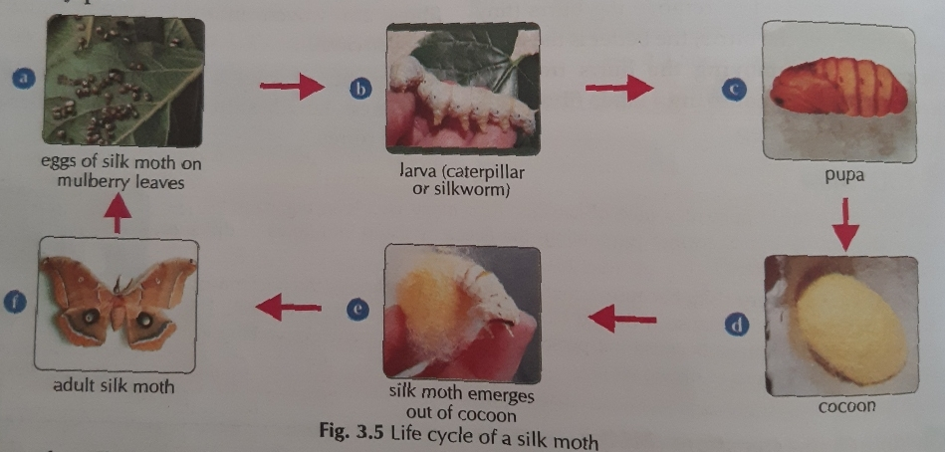

- What is sericin? How is it softened?
Sericin is a water soluble protective gum. The liquid silk secreted by the silkworm is coated with sericin which solidifies on contact with air and becomes Silk fibre. It is soften by hot water.

- Long answer questions.
- What is meant by the following terms?
- Shearing of sheep
The process of removing the hair from the body of a sheep is called shearing.
- Sorting of wood
The process of separating the long fine quality fleece from the remaining inferior quality or broken pieces is called sorting of wool.
- Combing of wool
The process of removing the burrs from the fleece is called combing of wool.

- Write the various steps involved in the production of silk cloth from silk moth.
The following steps are involved in the production of silk cloth from Silk moth.
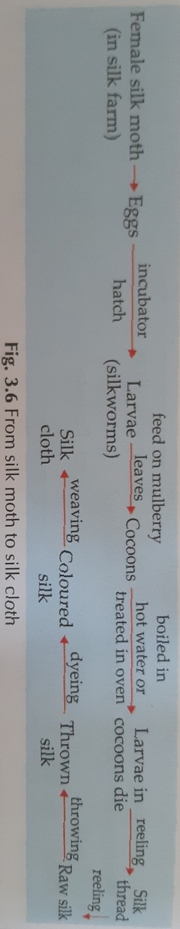
- Describe the process of wool production.
Wool is obtained from the Sheep by a long process which involves the following steps.
- Shearing: The hairs are removed from the body of sheep that is done manually with large razors or with an electrically driven shearing machine.
- Scouring: The fleece of sheep is washed to remove dust, dirt, sweat, grease etc.
- Sorting: The long fine quality of fleece is separated from the remaining inferior quality or broken pieces.
- Combing: The burrs are removed from the fleece. In this step the fibres are straightened.
- Dyeing: After coming, the fibres obtained are dyed in various colours.
- Spinning: The straightened fibres are spun or twisted together to make yarn which is either knitted or woven.

- Removal of sheep wool is called shearing. Shearing is done in early summers and not in winters.
- Why is shearing done in summers?
Shearing is done in early summers so that the hair of sheep grow again before the onset of winterrs and protect them from the cold winters.
- Which value does this ac show?
Kindness and care for the animals.

- High order thinking skills questions.
- If we burn silk fibre, it gives a smell of burning hair why?
Silk fibres on burning gives smell of burning hair because it is an animal fibre and is made up of a protein.
- Animal activists are against the silk production. Why?
Animal activists are against the silk production because in the process of obtaining silk, a large number of cocoons containing silkworms are boiled in hot water to losen the Silk thread. To obtain a little amount of cell a large number of silkworms are killed.

