PARAGON CONVENT SCHOOL, CHANDIGARH
CH-6
PHYSICAL AND CHEMICAL CHANGES
Summary:
- There are two types of changes: physical and chemical changes.
- A change in which only the physical properties of any substance get changed and no new substance is formed is called a physical change.
- A change in which one or more new substances with entirely different chemical composition and properties from the original substances are formed is called a chemical change.
- A chemical reaction could be endothermic or exothermic.
- There are different types of chemical reactions: combination reaction, decomposition reaction, displacement reaction and double displacement reaction.
- Rusting of iron is a chemical change in which iron reacts with oxygen in the presence of moisture and iron oxide is formed.

MCQs page no- 80

- B
- B
- D
- A
- C

SECTION - A
- Oral questions.

- How can you say that cutting of a paper is a physical change?
Cutting of paper is a physical change because no new substance formed only physical state that is size of paper is changed.

- What is a chemical change? Give two examples of chemical changes.
A change in which one or more new substances with entirely different chemical composition and properties from the original substances are formed is called chemical change. For example burning of tubes crackers, cooking and digestion of food, change the colour of cut fruits and vegetables.

- Give two methods of preventing the rusting of iron.
(i).Galvanization coating iron with other metals
(ii)Coating iron surface with paint or grease
(iii)By converting iron into alloy.

- Science quiz.

- What type of change is melting of wax?
Physical change.
- What are essential conditions for rusting of iron objects?
Presence of Oxygen and water or water vapour.
- What are the constituent metals of stainless steel?
Iron carbon magnesium chromium and Nickel are the constituents of stainless steel.

WORKSHEET
- Tick the correct options.

- D
- C
- C
- B

- Circle the odd one out.

- Photosynthesis in plants this is a chemical change where as others are physical changes.
- Grinding of a substance this is a physical change where as others are chemical changes.
- Hammering of metals this is a physical change where the others are chemical changes.

- Fill ups.

- State
- Evaporation
- Weak
- Physical

SECTION - B
- MCQs.

- A
- D
- C

- Very short answer questions.

- Give two examples of physical changes?
(i) stretching of rubber band
(ii) grinding of a substance.
(iii) expansion and contraction of a substance on heating and cooling.
(iv) melting of wax.
(v) formation of clouds.

- What happens when magnesium oxide is dissolved in water?
When magnesium oxide is dissolved in water it forms magnesium hydroxide.

3.What type of change is burning of coal?
Chemical change

- Short answer type-I questions.

- What is meant by rusting of iron?
Iron objects like Iron nails Grills railings and pipes when kept in moist air for a few days get covered with a brown powdery substance called Rust. This process is called rusting of iron.

- State any two conditions necessary for the rusting of iron?
The two conditions necessary for the rusting of iron are
(i). Presence of air or oxygen
(ii). Presence of water or water vapours.

- Why is melting of ice to form water considered a physical change?
Melting of ice does not form any new substance. Ice and water both have the same chemical composition. Only change in physical state takes place during the process thus the melting of ice is a physical change and not a chemical change.

- Short answer type-II questions.

- What are the characteristics of physical changes?
- Only physical properties like size shape colour and state change during a physical change.
- No new substance is formed.
- Generally a physical change is reversible.
- Generally no overall energy change takes place.
- Chemical composition of a substance remains the same during a physical change.

- What are the characteristics of chemiical changes?
- During chemical change one or more new substances are formed.
- Chemical changes are permanent. Thus a chemical change cannot be reversed by simple physical methods.
- During a chemical change net change in energy takes place. A large amount of energy is either given out or absorbed in the form of heat or light. For example burning of fuel produces large amount of heat.
- During chemical change both the physical and chemical properties of a substance are changed.

- Why is explosion of crackers is considered a chemical change?
Explosion of crackers is a chemical change because during burning of crackers new substances are formed and heat light sound and gases are produced.

- Does the change in chemical properties take place during a chemical change?
Yes the chemical properties of a substance get changed during a chemical change. This is because in a chemical change entirely new substances with new chemical composition are formed.

- Ram and Raheem are best friends. Raheem goes to Ram’s house to celebrate Diwali. Both are burning crackers. Suddenly a spark falls on Raheem’s arm. Ram immediately washes Raheem’s hand and applies a cream for burns.

- What type of a change is burning of crackers?
Burning of crackers is a chemical change.
(b.) do you think burning of crackers is good for environment?
No burning crackers is not good for environment as it causes air pollution.
- Which value is shown by Ram here?
Friendship, religious, harmony, concern and care for friends.

- Long answer questions.
- Write the difference between physical and chemical changes?
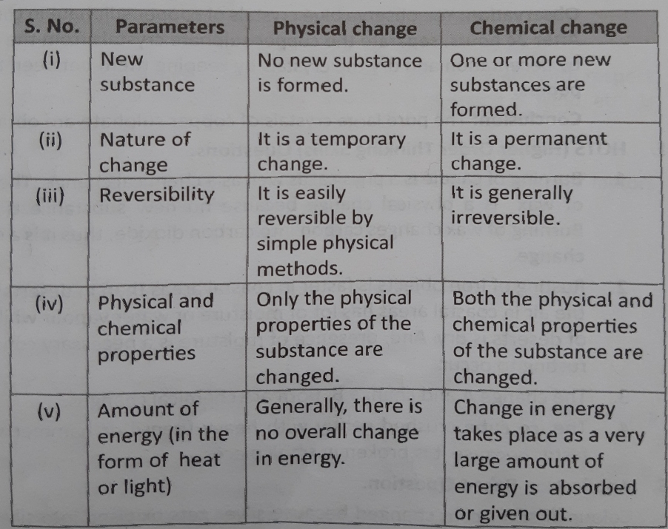

- HOTs questions.

- How is the burning of a candle a physical as well as a chemical change?
Burning of candle is a physical as well as chemical change. The melting of wax is a physical change because no new substance is formed where as burning of wax changes carbon into carbon dioxide therefore it is a chemical change.

- Rusting of iron objects is faster in coastal areas than in deserts. Why?
Rusting of iron objects is faster in coastal areas than in desert because the air in coastal areas has lot of moisture or water vapours while the air in deserts is dry. Presence of moisture is a necessary condition for rusting of iron to take place.

- Change A: animal waste is acted upon by anaerobic bacteria to produce biogas.
Change B: biogas is burnt as fuel.
The change A and change B both are chemical changes.

- Which ice cube will melt fastest? Why?
- The ice cube left on the kitchen counter.
- The ice cube left in a hot spot.
- The ice cube with salt on it.
- The ice cube crushed gently with a heavy utensil or a hammer.
The ice cube crushed gently with heavy utensil or hammer will melt faster because it is broken in small pieces.

- Application based questions.

- Jai was very fond of collecting coins of different metals. One day he observed that the colour of silver and copper coins had changed. Explain reason for his observation.
Colour of Silver coin changes because silver gets oxidized into Silver oxide. Copper changes its colour because chemical reaction occurs and it changes to Green coloured copper carbonate. Copper and silver are highly reactive with air)

