PARAGON CONVENT SCHOOL, CHANDIGARH
CH-10

RESPIRATION IN ORGANISMS
Summary:
- Respiration is the process of taking in oxygen, using it for the release of energy by breakdown of food, and eliminating the waste products – carbon-di-oxide and water.
- Respiration involves two steps: external respiration and internal respiration.
- There are two types of respiration: aerobic respiration and anaerobic respiration.
- No of times a person breathes in a minute is called the breathing rate. The human respiratory system consists of following organs: nose, nostrils, nasal cavity, trachea, lungs, bronchi, bronchioles and alveoli.
- In Unicellular organisms like amoeba, paramecium exchange of gases takes place by diffusion through cell membrane.
- Insects like grasshopper and cockroaches have a respiratory system called as tracheal system.
- Earthworm breathes through its skin. Whereas frogs have a pair of lungs to breathe on land and in water it breathe through its moist skin.
- Fish has special organ for breathing called as gills.
- Like animals plants also respire for their survival. The exchange of gases takes place through stomata present on leaves, root hair and lenticels present on the stem of the plant.
MCQs page no- 132
- A
- C
- B
- D
- D
MCQs page no- 135,136
- A
- B
- D
- D
- C
SECTION - A
- Oral questions.

(i) external respiration (breathing)
(ii) internal respiration (cellular respiration)
- The taking in air, rich in oxygen, into the body is called inhalation.
- The giving out air, rich in carbon di oxide, outside the body is called exhalation.
- (a) During exercise, breathing rate increases.
(b) While sleeping breathing rate decreases.
- Science quiz.
- Trachae
- Spiracles
- (i) Stomata (ii) Lenticels
- (a) gills (b) trachea (c) moist skin
(d) lungs (on land ), moist skin (in water)

WORKSHEET
- Tick the correct options.
- C
- C
- D
- D
- Circle the odd one out.
- Stomach : Stomach is the part of digestive system, whereas others are the parts of respiratory system.
- Sulphuric acid: Sulphuric acid is an acid whereas others are produced during anaerobic respiration.
- Earthworm: Earthworm breathes through its moist skin whereas others breathe through spiracles.
- Oesophagus: Oesophagus is the organ of digestive system, whereas others are organs of respiratory system.

- Fill ups.
- Breathing rate
- Bronchi
- Aerobes
- Upwards, outwards

SECTION - B
- MCQs.
- A
- A
- A
- B

- Very short answer questions.
1.
- cockroach
- fish
- earthwarm/ frogs
- humans/ frogs
2. The number of times a person breathes in a minute is called the breathing rate. The breathing rate of an adult human being at rest is 15-18 times in a minute.
3. Respiration is the process of taking in oxygen, using it for the release of energy by the breakdown of food, and removing the waste products- carbon di- oxide and water.
4. During exhalation, ribs move downwards and inwards, while the diaphragm relaxes and moves downward to its original position.
5. Anaerobic respiration.

- Short answer type-I questions.
- We should breathe only through the nose because the hair and the mucus present on the inner lining of nostrils trap unwanted particles and germs and prevent their entry into the nasal passage.

S.No. | Parameters | Breathing | Cellular Respiration
(1) | Process | It is a physical process in which exchange of gases (oxygen and carbon di-oxide) takes place. No chemical reaction takes place. | It is a biochemical process in which the breakdown of food takes place.
(2) | Energy | Energy is not released. | Energy is released.
(3) | Occurrence | It occurs outside the cells. | It occurs inside the cells.
(4) | Enzymes | Enzymes are not involved. | Enzymes are not involved at certain stages of respiration.

- During inhalation
- The ribs are pushed upwards and outwards.
- The diaphragm, contracts and moves downwards.
- The taking in of air, rich in oxygen, into the body is called inhalation. The giving out of air, rich in carbon dioxide, outside the body is called exhalation.
- The breathing becomes faster during exercise because when we do heavy exercise, we need extra energy. We breathe fast and take deep breaths. As a result, more oxygen is inhaled and supplied to our cells. It speeds up the breakdown of food and more energy is released to fulfill our requirement.

- Short answer type-I questions.
- The oxygen of the air diffuses in from the thin walls of the alveolus into blood capillaries. The oxygen combines with haemoglobin in the blood to form oxyhaemoglobin which is carried to all the cells of the body. Similarly, carbon dioxide produced by breakdown of food during respiration enters the blood and reaches alveolus in the lungs through diffusion.
2.
S.No | Parameters | Aerobic respiration | Anaerobic Respiration
1 | Presence of oxygen | It takes place in the presence of oxygen | It takes place in the absence of oxygen
2 | Breakdown of food | Complete breakdown of food(glucose) takes place | Incomplete breakdown of food takes place.
3 | End products | The end products are carbon di oxide and water. | The end products are carbon di oxide and alcohol.
4 | Amount of energy released | A large amount of energy is released. | A very small amount of energy is released.
5 | Occurrence | It takes place in living organisms. | It takes place in yeast and in some form of bacteria.

3. The roots of the plants have tiny hair called root hair. The root hair are in contact with the air present in the soil particles. Oxygen from the air in the soil particles diffuses into the root hair and reaches all the cells of the plant, where it is used for respiration. Carbon dioxide produced during respiration goes out through the root hair by diffusion.
4. Photosynthesis is the process of synthesizing food by the utilization of carbon dioxide and releasing of oxygen whereas respiration is the process of taking in oxygen for the breakdown of food and releasing carbon dioxide and water.
- Long answer questions.
- M
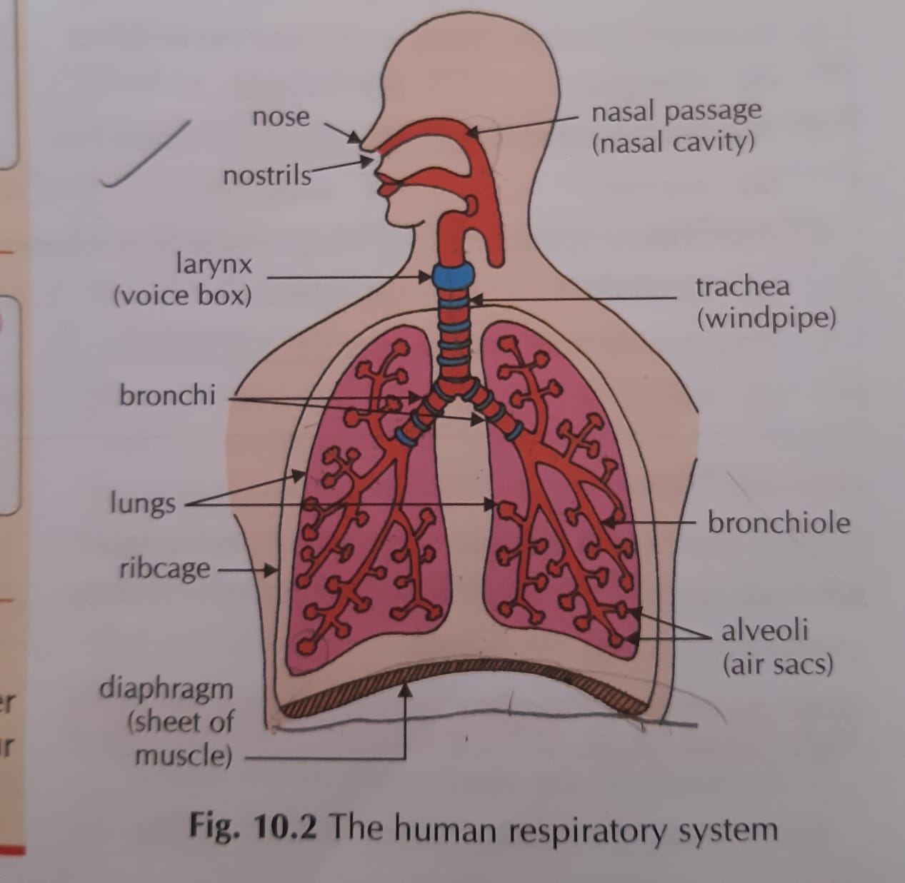
- (a). Insects: Insects breathe through spiracles. From spiracles oxygen goes into trachea, diffuses into the body tissues and reaches every cell. Oxygen is used for the breakdown of food to produce energy and carbon dioxide. This carbon dioxide from the cells goes into the tracheae and goes out of the body through spiracles.
(b) Earthworms: Earthworms breathe through their moist skin. The oxygen enters the body through the skin by diffusion. After respiration the carbon dioxide diffuses out through the skin.
(c). Frogs: Forgs live both on land and in water. On land frogs breathe through lungs. In water they breathe through their moist skin.
(d). Fish : The fish breathes by taking water through its mouth and sending it over to the gills which are found in both sides of its head. The blood vessels present in the gills absorb the dissolved oxygen from the water and send it to all parts of the body. The carbon dioxide from different parts of the body comes back into the gills by the blood and is then expelled to the surrounding area.
3.
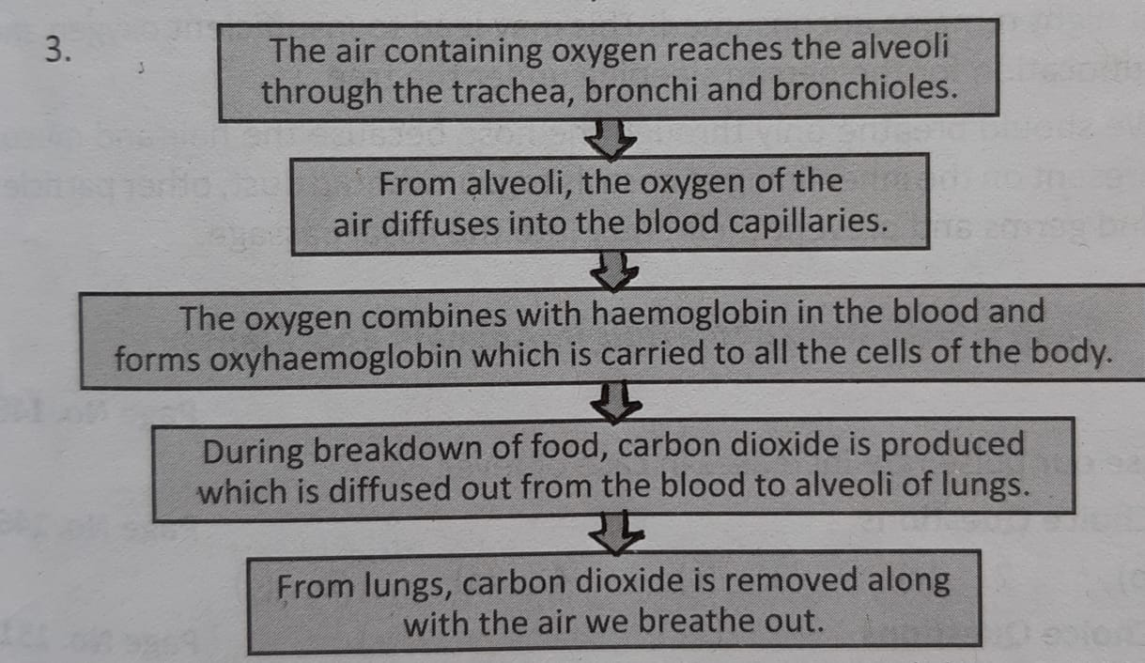
4. (a) Nitika felt pain due to a muscle cramp which happened because of the anaerobic respiration in the muscle cells in which lactic acid is formed.
In the muscle cells
Glucose lactic acid + Energy
Anaerobic respiration

(b) kind, concerned, compassionate and helping in nature.
5. (a) Figure a shows inhalation and figure b shows exhalation.
(b) During inhalation the intercostals muscles contract the ribs are pushed upwards and out words. The diaphragm contracts and moves downwards. It increases the space in the chest cavity. Thus the air rushes into the lungs. The lungs get filled up with air and expand. During acceleration intercostal muscles relax the ribs move downwards and in words. The diaphragm relaxes and moves from words to its original position. It decreases the space in the chest cavity and the air rushes out of the lungs.
- HOTS questions.
- We will not be able to breathe if our diaphragm shows no movement.
- Frog is an amphibian, i.e. it lives both on land and in water. That is why it requires a dual mode of breathing. Therefore it breathes through lungs on land and moist skin in water.
- An athlete breathes faster and deeper than usual after finishing the race because he needs to inhale more oxygen, which in turn speeds up the breakdown of food and releases more energy.
- Sneezing prevents the entry of unwanted foreign particles from inhaled air and thus, a dust free clean and germ free air enters into the body.
- Application based questions.
- It is not advisable to sleep under the trees at night because during the night, in plants only respiration takes place and they release carbon di oxide in the air.
Since, photosynthesis takes place only during the day, the carbon di oxide produced at night remains unconsumed. This may lead to insufficient oxygen and suffocation for the person sleeping under the tree.
- We should only breathe through the nose because the hair and the mucus present on the inner lining of nostrils trap unwanted dust, other particles and germs and prevents their entry into the nasal, passage

